**For more information:**

Sarah Wynn Benton

BRAVE Public Relations

404.233.3993  
[sbenton@emailbrave.com](mailto:sbenton@emailbrave.com)

**FOR IMMEDIATE RELEASE**

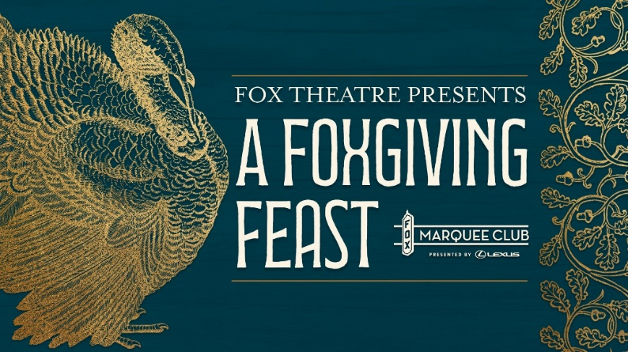

**Fox Theatre Presents Its Inaugural Friendsgiving Event, A Foxgiving Feast on Nov. 18***Tickets are on sale now at foxtheatre.org*

**ATLANTA (Oct. 18, 2024) – The Fox Theatre** is excited to announce its first-ever Friendsgiving celebration, **A Foxgiving Feast**,on **Monday, Nov. 18, from 6 to 9 p.m.** in the exclusive Marquee Club presented by Lexus. Guests are invited to gather for an unforgettable evening filled with friendship, gourmet Thanksgiving-inspired dishes, select wines and more. General admission tickets start at **$75** (plus applicable fees)and include access to the event, a delectable Thanksgiving-themed menu, a Lexus-sponsored artist print gift and an event-branded photo opportunity. Early purchase is encouraged as prices may increase closer to the day of the event.

Premium drinks and signature cocktails are available for purchase. For those looking to enhance the experience, VIP tickets are available for **$150** and include a private wine tasting led by renowned sommelier and winemaker André Mack, along with a memorable photo on the Fox Theatre’s iconic stage. For information on all shows and events, visit [foxtheare.org.](https://www.foxtheatre.org)

“Thanksgiving is all about expressing what we’re grateful for, and here at the Fox, we’re grateful for the shared experiences we create with our guests,” said Jamie Vosmeier, vice president of sales and marketing at theFox Theatre. “Whether you’re coming with family or not, during A Foxgiving Feast, we’ll be your family, and we’re honored to offer one more memorable experience for everyone.”

In the spirit of the season, attendees are encouraged to bring canned goods to donate to the Midtown Assistance Center, supporting efforts to help the homeless this holiday season. To learn more, visit [midtownassistancecenter.org.](https://midtownassistancecenter.org/food-pantry-assistance/)

**###**

**About André Mack**André Mack is an award-winning sommelier, winemaker, and designer who has significantly impacted the wine world. After earning accolades as a sommelier at Thomas Keller’s renowned restaurant, The French Laundry, Mack went on to become the first African American to win the prestigious title of Best Young Sommelier in America. He is the founder of Maison Noir Wines, a bold wine brand that combines his love for wine with his unique perspective on culture and design. Mack’s wines have been featured in top restaurants across the country, and he is celebrated for his approachability and passion for making wine an experience everyone can enjoy.

**About the Marquee Club presented by Lexus**The Marquee Club presented by Lexus is the Fox Theatre’s premium event space, offering guests an elevated experience unlike any other in Atlanta. Spanning over 10,000 square feet, the club features multiple luxurious environments, including indoor and outdoor lounges, private bars, and rooftop access with stunning city views. Designed to enhance every visit to the Fox, the Marquee Club offers exclusive amenities such as early entry prior to a show, private restrooms, and top-tier food and beverage options. Whether attending a performance or a special event, the Marquee Club provides an unmatched level of comfort and service for its guests.

**About the Fox Theatre**The Fox Theatre is one of Atlanta's premier venues for live entertainment, welcoming more than 200 performances a year in its 4,665-seat theatre. From concerts to ballets, comedy, and movies, the historic venue attracts more than 500,000 visitors annually. The theatre hosts over 100 annual private events like wedding receptions, trade shows, corporate meetings, and association functions in two fabulous ballrooms. The Fox’s premium Marquee Club, presented by Lexus, is a 10,000 sq. ft, three-story luxury bar accessible to all Club Level ticket holders or annual members of the Fox Theatre. As a 501(c)(3) nonprofit arts organization, the Fox Theatre is a fiercely protected landmark and nationally acclaimed theatre today. The Fox Theatre proudly acknowledges its partners' generous support: Coca-Cola, Georgia Natural Gas, Georgian Terrace Hotel & Livingston Restaurant, Humana, Lexus, Northside Hospital, and Regions Bank. Tickets for all events are available at [FoxTheatre.org](https://protect-us.mimecast.com/s/v0QXCOYoRKcNvKACmEBXS?domain=secure-web.cisco.com), or toll-free at 855-285-8499. Stay connected by following the Fox Theatre on social via @theFoxTheatre on [Instagram](https://protect-us.mimecast.com/s/SE2wCPNp8Li03x4HxEXzY?domain=secure-web.cisco.com), [Twitter](https://protect-us.mimecast.com/s/6oQPCQWqRMHXoW6i7XoPc?domain=secure-web.cisco.com), [and Facebook](https://protect-us.mimecast.com/s/kDgUCR6r7NtG5LrIZrWlF?domain=secure-web.cisco.com).

Notable accolades include 2023 Billboard Magazine #2 Highest Grossing Theatre Worldwide (5,000 seats or less); 2023 VenuesNow Magazine #2 Year-End Top Stops (2,001-5,000 seats); 2022 IEBA Theatre of the Year; 2021 Billboard Magazine #1 Highest Grossing Theatre Worldwide (5,000 seats or less); 2021 Pollstar Magazine #2 Theatre Worldwide in Ticket Sales and 2021 VenuesNow Magazine #2 Year-End Top Stops (2,001-5,000 seats). Additionally, in 2019, the Fox Theatre was honored with the VenuesNow #1 Top Stop of the Decade Award for Tickets Sold, further cementing its reputation as a premier entertainment venue.